**ASSIGNMENT 10**

**Problem Statement:**

Create a GUI program which has 4 buttons assigned to colors Red, Green, Blue and Reset. When a button is pressed appropriate color should be displayed.

CODE:

import java.awt.*;

import javax.swing.*;

import java.awt.event.ActionEvent;

import java.awt.event.ActionListener;

class Buttons{

Buttons(){

JFrame f = new JFrame("Button Assignment");

f.setDefaultCloseOperation(JFrame.EXIT_ON_CLOSE);

f.setSize(400, 200);

JPanel panelMain = new JPanel();

final JButton red_button = retButton("buttons/button_red.png");

final JButton green_button = retButton("buttons/button_green.png");

final JButton blue_button = retButton("buttons/button_blue.png");

final JButton reset_button = retButton("buttons/button_reset.png");

Color defaultColor = panelMain.getBackground();

ActionListener buttonListener = new ActionListener(){

@Override

public void actionPerformed(ActionEvent ae){

Object o = ae.getSource();

if(o == red_button) panelMain.setBackground(Color.RED);

else if(o == green_button) panelMain.setBackground(Color.GREEN);

else if(o == blue_button) panelMain.setBackground(Color.BLUE);

else if(o == reset_button) panelMain.setBackground(defaultColor);

}

};

red_button.addActionListener(buttonListener);

green_button.addActionListener(buttonListener);

blue_button.addActionListener(buttonListener);

reset_button.addActionListener(buttonListener);

panelMain.add(red_button);

panelMain.add(green_button);

panelMain.add(blue_button);

panelMain.add(reset_button);

f.add(panelMain);

f.setVisible(true);

}

public static JButton retButton(String address){

JButton button = new JButton(new ImageIcon(address));

button.setBorderPainted(false);

button.setContentAreaFilled(false);

button.setFocusPainted(false);

button.setOpaque(true);

button.setMargin(new Insets(-5, -5, -5, -5));

return button;

}

public static void main(String[] args) {

new Buttons();

}

}

**OUTPUT:**

RED:

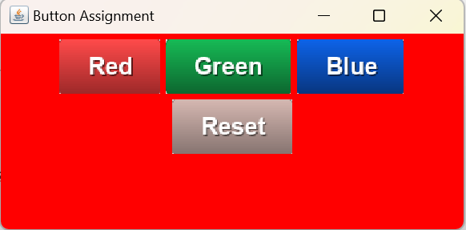

GREEN :

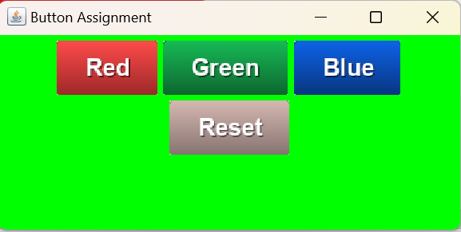

BLUE :

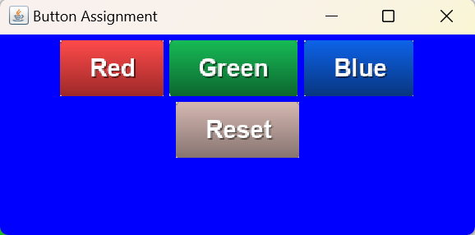

RESET:

